**Project**

**Design Phase-II**

**Data Flow Diagram s User Stories**

|  |  |
| --- | --- |
| Date | 26 june 2025 |
| Team ID | LTVIP2025TMID50687 |
| Project Name | visualizing housing market trends: an analysis of sale prices and features using tableau |
| Maximum Marks | 4 Marks |

**Data Flow Diagrams:**

**Purpose:**

This diagram represents the entire analytics system as a single process, showing how external users interact with it.

**External Entities:**

* **Tourist (Web/Mobile User):** Interacts with dashboards to explore heritage sites.
* **Researcher:** Applies filters and exports data for analysis.
* **Administrator:** Uploads data, manages users, and configures dashboard permissions.
* **UNESCO Data Source:** Provides heritage site data (CSV, Excel, API).

**Process:**

* **Heritage Analytics System in Tableau Data Stores:**
* Tableau Dashboard Repository
* User Profile Database
* Raw Data Store

**Data Flows:**

* Users request and receive visualizations.
* Admins upload or modify datasets.
* Researchers export reports.
* System fetches data from UNESCO sources.

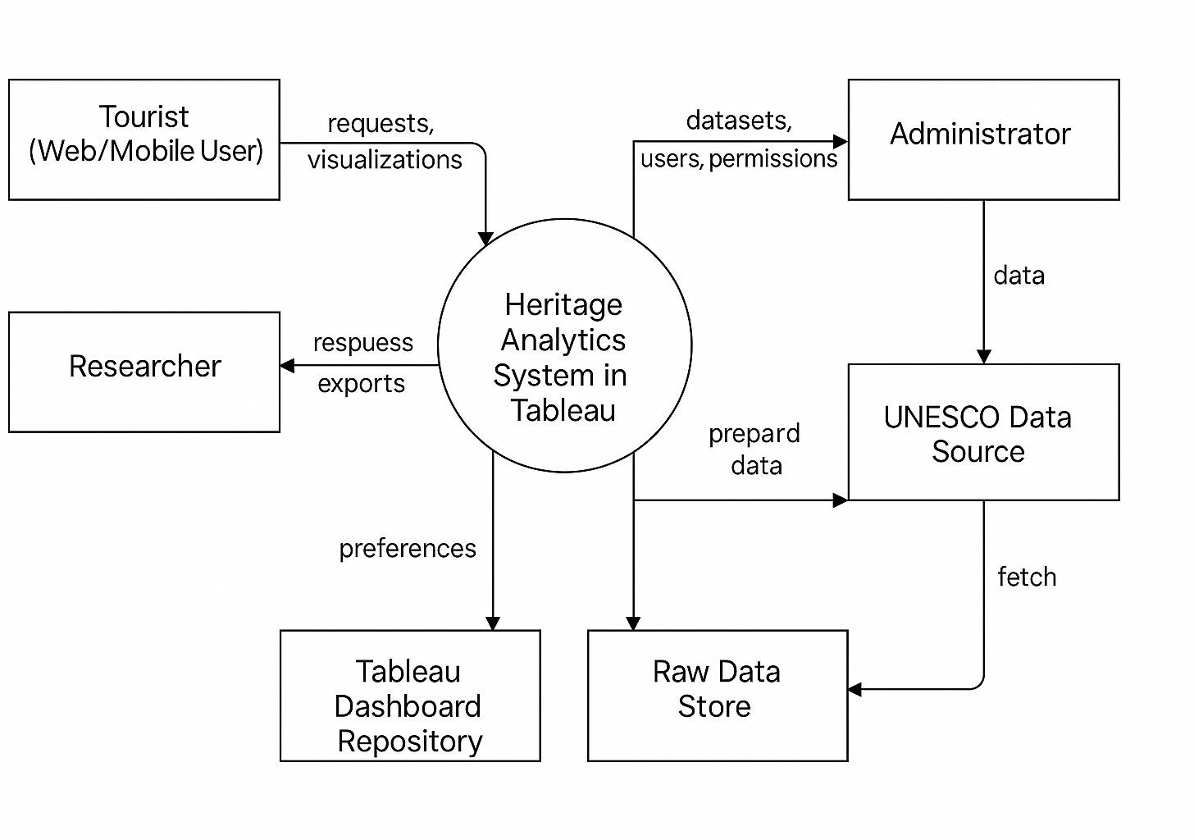

**User Stories**

Use the below template to list all the user stories for the Heritage Treasures

|  |  |  |  |  |  |  |
| --- | --- | --- | --- | --- | --- | --- |
| **User Type** | **Functional Requireme nt (Epic)** | **User Story Numb er** | **User Story / Task** | **Acceptanc e criteria** | **Priorit y** | **Relea se** |
| Tourist(web User) | Site Exploration | USN-1 | As a tourist,I can view a map of UNESCO  sites by region or country. | Interactive map shows all sites with  hover/click info by  location | High | Sprint- 1 |

|  |  |  |  |  |  |  |
| --- | --- | --- | --- | --- | --- | --- |
| **User Type** | **Functional Requireme nt (Epic)** | **User Story Numb er** | **User Story / Task** | **Acceptanc e criteria** | **Priorit y** | **Relea se** |
| Tourist(Mob ile user) | Mobile Access | USN-2 | As a mobile  user,I can view dashboards optimized for smaller  screens. | Dashboard s load properly on mobile without layout  breaks. | High | Sprint- 1 |
| Researcher | Data filtering | USN-3 | As a researcher  ,I can filter sites by cultural  /natural type and year of  inscription. | Filter results  dynamicall y update  visualiztion s. | High | Sprint- 1 |
| Tourist(Web User) | Search  Functionali ty | USN-4 | As a user, I can search for the heritage sites by name. | Search returns relevant  site entries with links  to detailed views. | Mediu m | Sprint- 2 |
| Administrat or | Data  Upload | USN-5 | As an admin ,I can upload  new or updated UNESCO  dataset CSVs to Tableau. | Data  uploads  successfull y and  reflects in dashboard s after  processing. | High | Sprint- 1 |
| Administrat or | User Role Manageme nt | USN-6 | As an admin,I can manage access levels for  tourist,researc | Different user types see only the  dashboard | High | Sprint- 2 |

|  |  |  |  |  |  |  |
| --- | --- | --- | --- | --- | --- | --- |
| **User Type** | **Functional Requireme nt (Epic)** | **User Story Numb er** | **User Story / Task** | **Acceptanc e criteria** | **Priorit y** | **Relea se** |
|  |  |  | her, and adminusers. | s they are allowed to access. |  |  |
| Researcher | Data Export | USN-7 | As a researcher  ,I can export site data and  graphs to Excel or PDF. | Exported data matches  on-screen visualizatio ns  accurately. | Mediu m | Sprint- 2 |
| Tourist(mob ile user) | Bookmark Sites | USN-8 | As a mobile user,I can bookmark  heritage sites for later reference. | Book marked sites in  user profile for future  visits. | low | Sprint- 3 |
| Researcher | Time- Series analysis | USN-9 | As a researcher I can view  trends of site additions over decades. | Line/bar charts show  trends by continent and  category over time. | Mediu m | Sprint- 2 |
| Administrat or | Scheduled dash board sharing | USN- 10 | As an admin,I can schedule dashboard reports to be sent  weekly,Dashbo ard sharing. | Reports are automatica lly sent at  defined times. | Mediu m | Sprint- 3 |
| Tourist (web User) | Cultural vs Natural | USN- 11 | As a Tourist ,I can compare  cultural and | A dual- category  chart | Mediu m | Sprint- 2 |

|  |  |  |  |  |  |  |
| --- | --- | --- | --- | --- | --- | --- |
| **User Type** | **Functional Requireme nt (Epic)** | **User Story Numb er** | **User Story / Task** | **Acceptanc e criteria** | **Priorit y** | **Relea se** |
|  | Compariso n |  | natural sites by region. | visualizes counts and details of  each type. |  |  |
| Administrat or | Audit Logs | USN- 12 | As an admin,I can view logs of who  accessed dashboards and when. | Logs  display  usernames and timestamp s for dashboard interaction s | Mediu m | Sprint- 3 |